
 Client Handover Manual

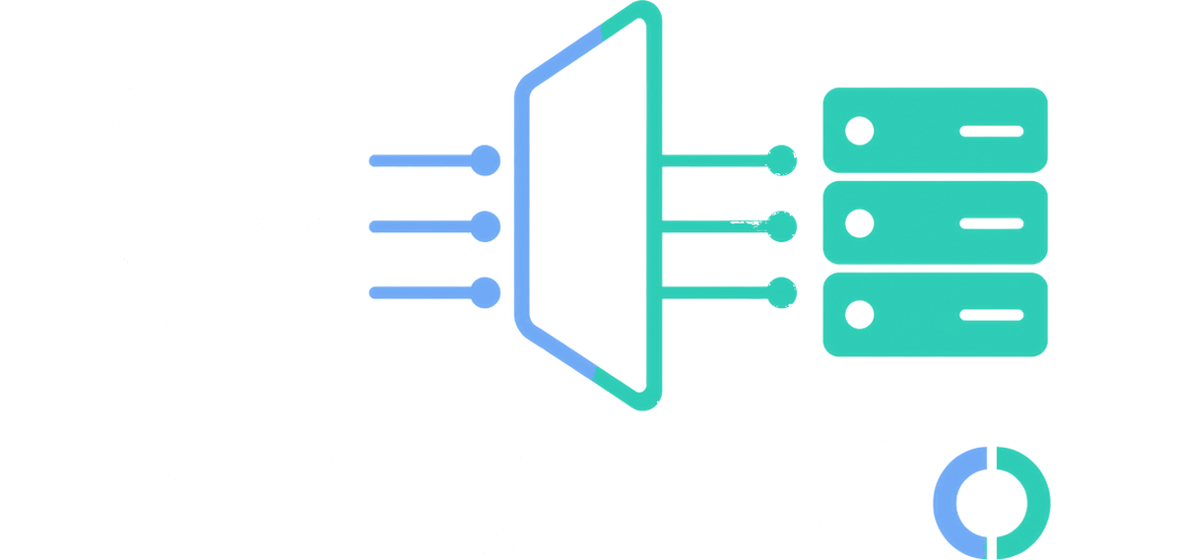

Deployment &
Installation Guide
Part I · Version 1.0

  Stealth  Architecture |   Zero  Exposure |   Encrypted  by Design

Tekmonks Reflection

1 What Reflection does
Reflection publishes a TCP or UDP service that is reachable from a public mirror server, while the real service stays on a private reflector server. A reflector creates encrypted control/data channels to the mirror. When a client connects to the published mirror port, Reflection assigns one channel and connects to the configured origin service.
Client → public mirror:published port → encrypted Reflection channel → reflector → private origin service
Figure 1. Connection path from a client to the private origin service.
This is a transport-layer relay. It does not understand HTTP, TLS, databases, or application protocols; it forwards TCP streams or UDP datagrams. Use it only where a reverse TCP/UDP relay is the intended architecture.

2 Components and where they run
Table 1. Reflection components and where they run.
Component | Run on | Purpose
Mirror | Public/reachable host | Receives reflector control/data channels and opens the client-facing listener on demand.
Reflector | Network that can reach the origin | Connects to the mirror, maintains a TCP channel pool, and opens connections to the origin.
Origin service | Usually private | The existing TCP/UDP service being made reachable. It is not part of this repository.

3 Requirements
- Node.js with the built-in net, dgram, crypto, cluster, and filesystem modules. The repository has no package.json and no third-party Node dependency install step.
- Two hosts with network connectivity from reflector to mirror control/data ports.
- An origin service reachable from the reflector on the configured host and port.
- Permission to listen on the selected ports. Use ports above 1024 unless the service account has the required capability.
- The mirror and reflector must use the same conf/crypt.json values. Control traffic and TCP relay control messages use the shared key; the optional AES extension has its own conf/aes.json secret.
Check Node before deployment:
node --version
node -e "require('net'); require('dgram'); require('crypto'); console.log('Node runtime OK')"

4 Before installation: choose ports and firewall rules
Choose non-conflicting ports. Do not expose the control, heartbeat, or firewall-control ports to the Internet. Restrict them to reflector/admin addresses. The published service port is the only port normally open to clients.
IMPORTANT · UDP
The implementation starts its heartbeat server with Node’s TCP net API even for the UDP mode. Keep the heartbeat port reachable over TCP until a future release.

5 Installation
Perform these steps on both hosts.
- Copy the complete reflection directory to a stable location, for example /opt/reflection.
- Create a non-login service account, for example reflection.
- Give that account ownership of the installation and ensure it can create /opt/reflection/logs.
- Keep conf/ readable only by the service account because it contains secrets.

6 Secure the configuration first
The supplied configuration contains sample/default secrets and example addresses. Treat it as a template, not production configuration.
- Generate two new high-entropy secrets: one for key, one for heartbeat_key.
- Put them in conf/crypt.json on both hosts, with identical values.
- If using the AES traffic extension, replace conf/aes.json with the encrypted AES key expected by extensions/aes.js; otherwise do not enable that extension.
WARNING
Never put secrets directly in source control. Any string config value may instead use env:VARIABLE_NAME; Reflection resolves it from the process environment at startup.

Example crypt.json pattern using environment variables:
{
"key": "env:REFLECTION_CONTROL_KEY",
"heartbeat_key": "env:REFLECTION_HEARTBEAT_KEY",
"fips_mode": false
}
Set those environment variables in the service manager, not in a world-readable shell file. Both endpoints must receive exactly the same values. If FIPS is enabled on the installation system, then change fips_mode flag as true.

7 Configure a standard TCP relay

7.1 Mirror host: conf/mirror.json
Set the bind addresses and shared control ports. A conservative example:
{
"host": "0.0.0.0",
"port": 2000,
"heartbeat_tcp": 2001,
"keep_alive": 1000,
"timeout": 300000,
"firewall_enabled_tcp": false,
"firewall_enabled_udp": false
}
port is the Reflection control/data port, not the client-facing service port. The reflector asks the mirror to create the client-facing listener dynamically. host should be a specific public or private address where possible; use :: only when intentionally accepting IPv6.

7.2 Reflector host: conf/reflect.json
For an origin service at 10.0.0.25:8080, published as mirror port 1201:
{
"reflected_host": "10.0.0.25",
"reflected_port": 8080,
"mirror_host": "<mirror_ip>",
"mirror_port": 2000,
"mirror_heartbeat_tcp": 2001,
"mirror_service_host": "0.0.0.0",
"mirror_service_port": 1201,
"mirror_force_listener": true,
"pool_size": 5,
"mirror_connect_timeout": 20000,
"heartbeat_check_interval": 60000,
"dhcp_check": true,
"logfile": "reflector_tcp.log.ndjson"
}
reflected_* identifies the origin from the reflector’s network. mirror_* identifies the mirror control endpoint. mirror_service_* defines the public listener created on the mirror. pool_size is the number of idle TCP channels; it also caps the number of simultaneous TCP client sessions for this mapping. Size it for expected concurrency plus a small buffer.
For IPv4/IPv6 UDP, also set mirror_hostudpv4, mirror_hostudpv6, mirror_service_host_udpv4, mirror_service_host_udpv6, and ipv6enabled appropriately. Disable IPv6 (false) unless both hosts and firewall rules support it.

7.3 Start order and test
Start the mirror first, then the reflector:
cd /opt/reflection
node --env-file=.env mirror_tcp.js
cd /opt/reflection
node --env-file=.env reflect_tcp.js
NOTE
Do not regard an open TCP port alone as proof of success: confirm an actual application response.

curl -v http://<mirror_ip>:1201/

8 TCP, UDP, and multi-service launch commands
Table 2. Launch commands for each deployment mode.
Use case | Mirror command | Reflector command
TCP | node mirror_tcp.js | node reflect_tcp.js
UDP | node mirror_udp.js | node reflect_udp.js
Many TCP mappings | node mirror_tcp.js | node massreflect_tcp.js

8.1 Multiple TCP mappings
Use conf/massreflect.json when one reflector publishes multiple origins or multiple reflectors use the same mirror.
Each reflected_hosts string follows this syntax:
"origin-host:origin-port->published-bind-address:published-port"
NOTE
Can leave the Mirror_hostsudpv6 blank if using ipv4.

[
{
"reflected_hosts": ["216.116.72.174:80->[::]:1201","216.116.72.174:443->[::]:1202"],
"mirror_host": "<mirror_ip>:<mirror_port>",
"mirror_hostsudpv4": "<mirror_ipv4>:<mirror_port>",
"Mirror_hostsudpv6": "<mirror_ipv6>:<mirror_port>",
"mirror_heartbeat_tcp": 2001,
"mirror_heartbeat_udp": 1002
}
]





Support
Before contacting support, collect: the document revision shown on the cover; the output of node --version; the mirror and reflector log files under logs/*.ndjson for the affected time window; and the exact conf/*.json values in use, with every key, heartbeat_key, and aes.json key field redacted before sending them to anyone.
Email | [ insert support email address ]
Telephone | [ insert support telephone number ]
Hours | [ insert support hours and time zone ]

Reflection · Client Handover Manual
Part I · Deployment & Installation Guide · Version 1.0

Tekmonks © Tekmonks. All rights reserved.

